Vision and Scope

Smart Bite
Prepared by:
Mahmoud Samer 231006523
Rawan Atef 231005789
Retaj Ali 231005689
Rokaya Hamdy 231006586
Youssef Karim 231014449
Youssef Mahmoud 231006058
Department: Software Engineering
Prepared for:
Dr. Nada Mahmoud – Eng. Maha Talaat

Date: 10/12/2025

Document Revision
Version | Primary Author(s) | Description of Version | Date Completed
1.0 | Retaj Ali, Youssef Karim, Rokaya Hamdy, Rawan Atef, Youssef Mahmoud, Mahmoud Samer | Initial full version of the Software Requirements Specification for SmartBite – AI Recipe Maker. Includes introduction, requirements, use cases, and non-functional specifications. | 11/12/2025

Table of Contents

Section 1: Business Requirements 3
1.1. Current State and Challenges 3
1.2. Business Opportunity and Success Criteria 3
Section 2: Vision of the Solution 4
2.1. Vision Statement 4
2.2. Assumptions and Dependencies 4
Section 3: Scope 4
3.1. In Scope 5
3.2. Out of Scope 5
Section 4: Business Context 5
4.1. Stakeholders 5
4.2. Data Considerations 6

Section 1: BUSINESS REQUIREMENTS
The business requirements for SmartBite define the foundation for all system specifications and ensure alignment between user needs and business goals. The project was initiated to address the growing challenge of meal planning and food waste by offering an AI-based solution that generates recipes from available ingredients.These requirements were developed in collaboration with stakeholders, including developers, end users, and project sponsors, to capture the core purpose of the system — saving time, reducing food waste, and promoting healthy eating habits. They will guide all future design and development decisions to ensure the final product delivers measurable value and meets user expectations.

Current State and Challenges
In today’s fast-paced environment, many individuals struggle with meal planning due to time constraints, lack of cooking knowledge, or difficulty deciding what to make with available ingredients. As a result, people often resort to ordering food or letting ingredients go to waste, which leads to increased expenses and food waste. Existing recipe applications mostly focus on providing cooking instructions or diet plans, but they rarely connect what users already have at home with what they can cook instantly. The absence of an intelligent, ingredient-based meal generator presents a clear gap in the market. Users need a simple, intelligent, and efficient solution that helps them create meals from what they already own — without requiring expert cooking skills or extensive searching.

Business Opportunity and Success Criteria
The primary success of this initiative will be measured by user adoption rates, daily recipe generation volume, reduction in food waste, and positive user feedback. SmartBite’s success criteria includes fast recipe generation under 10 seconds, user satisfaction above 90%, and stable system uptime above 98%. Potential risks include delays in AI model training, limited dataset accuracy, or slow user acceptance in the initial rollout phase.

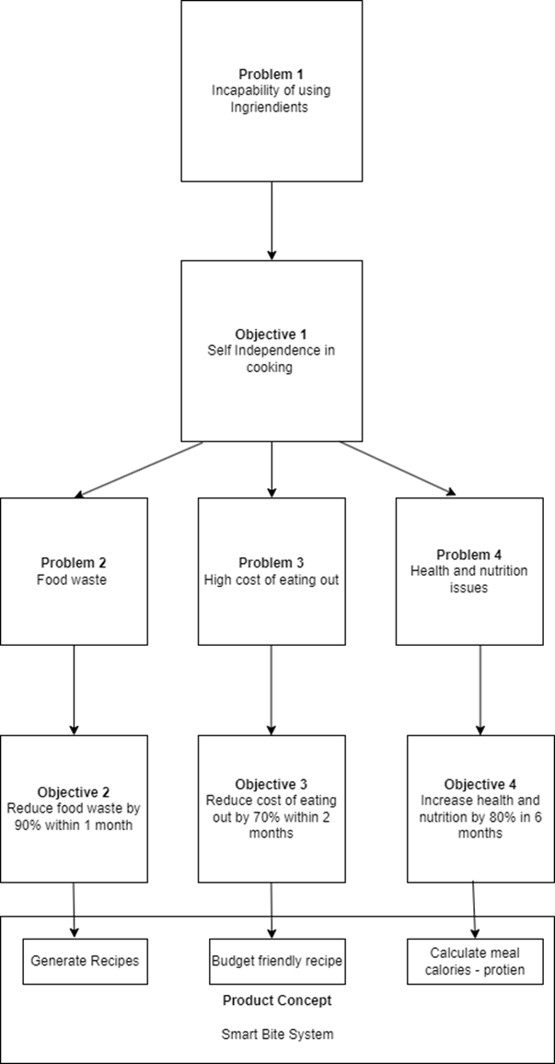

Section 2: VISION OF THE SOLUTION
This section establishes a long-term vision for the solution to address the business objectives. This vision will provide the context for making decisions throughout the course of the solution's life cycle.

2.1. Vision Statement
The vision of SmartBite is to create an intelligent and user-friendly mobile and web application that transforms the way people cook by connecting available ingredients to instant, customized recipe suggestions. By integrating an AI-driven ingredient recognition model and a rich recipe database, SmartBite will empower users to make quick, informed, and healthy meal choices. This solution will reduce food waste, save time, and make cooking more enjoyable and accessible to everyone, regardless of skill level.

2.2. Assumptions and Dependencies
It is assumed that users will have access to a smartphone or computer with an internet connection and a camera to capture ingredient images. The project depends on several external components, including a stable recipe database, third-party nutritional APIs, and a secure cloud infrastructure for storing and processing data. The accuracy of recipe generation depends on the quality of the AI model and the completeness of the ingredient dataset. The success of SmartBite also depends on user engagement and consistent app updates to improve the AI detection accuracy and recipe diversity.

Section 3: SCOPE
Smart Bite is not designed to replace the grocery store, meal delivery services or professional nutrition counselling. Instead, its role is focused & clear: to help users make the most of what they already have at home. The product directly addresses common problems like wasted groceries, limited cooking skills and lack of time to plan meals. The project is limited to converting the user’s existing ingredients into ready-to-cook recipes. It does not include external integrations such as online stores or health tracking services. These boundaries ensure that Smart Bite stays focused on its core purpose, bridging the gap between a cluttered fridge and a finished dish — while preventing scope creep.

3.1. In Scope
- Ingredient input by users
- AI-generated recipe suggestions
- Internal recipe database access
- Displaying nutritional information
- User-friendly interface for browsing recipes
- Saving and sharing your favorite recipes
- Displaying advertisements to Users
- Optional subscription to remove ads
- Basic user accounts

3.2. Out of Scope
- Online grocery delivery or shopping services
- Professional diet plans or medical nutrition advice
- Cooking video tutorials
- Real-time collaboration between users
- Recipe creation by chefs within the app
- Full e-commerce system beyond subscription for ads removal

Section 4: BUSINESS CONTEXT
This section summarizes some of the business issues around the initiative, including a list of key stakeholders as well as considerations around what data will be collected via the new solution and how it will be managed.

4.1. Stakeholders
Stakeholders are individuals, groups, or organizations that are actively involved in an initiative, are affected by its outcome, or can influence its outcome. The stakeholder list identifies the customers for this solution, states their major interests in the solution, and constraints or factors that limit the time, resources or budget available. Thinking this through will help build alignment on scope and reduce surprises down the road.
Example:

Stakeholder | Role | Interest
End users (Primary) | Users the Smart bite App | Reduce food waste, save money and have healthier diet
Investors | Provide funding for the project | Want growth, user engagement, and return on investment
Recipe database | Supply recipe information, nutritional data, and ingredient details | Provide various up-to-date recipes

4.2. Data Considerations
Smart Bite collects minimal personal data such as user login details, ingredient inputs, and saved recipes. All data is encrypted, stored securely on cloud servers, and managed by the development team. External integrations are limited to nutritional APIs. Access is restricted to authorized personnel, and strong security measures are in place to prevent unauthorized access or data breaches.

- Step 1 → Refer to simplified vision & scope template
- Step 2 → Refer to elicitation template

